Important Move-Out Information

Dear Current Residents,

It’s almost time to start packing again as the school year comes to an end, your lease expires May 19, 2023. It has been a pleasure serving you this year and we look forward to making your move-out as smooth as possible! For your convenience, we start conducting move out inspections beginning May 15, 2023. However, you are welcome to schedule a time for May 19, 2023 (last day of your lease). To better serve our residents, we can even extend the move-out inspection day through May 22, 2023 for apartments which have graduates participating in commencement ceremonies on Sunday or for apartments which have international students who have confirmed with the CIE they will be traveling to the airport via the charter that Monday morning. Remember, personalized move-out appointments are scheduled on a first-come-first-serve basis, so please schedule your inspection soon.

Tuesday April 25th & Wednesday April 26th: Schedule your Move-Out Inspection in-person in the Woods Leasing Office from 9:00 AM - NOON. Please designate ONE roommate to visit us on these days to schedule the apartment move-out inspection appointment.

Steps to take…
- Communicate with roommates and decide who will be last to move-out.
- Select a day/time that works best for everyone.
- Schedule a Move-Out Inspection time in our office between April 25-26th.

During the inspection date/time keys are collected, and you are presented with inspection results. No residents need to be physically present at inspection, but it’s always recommended.

*Your lease ends Friday May 19th

**Move-out inspections take 30 minutes and all personal belongings must be removed from the apartment prior to this appointment time unless you have re-signed for the Summer.

April 27, 2023: The Woods will assign a time for any apartments which did not schedule a move-out inspection.

How do I prepare my apartment for inspection? Below you will find a move-out preparation checklist with instructions, what our inspectors will look for, costs for damages, cleaning etc. This year more than ever please make sure you follow the instructions on this checklist as pricing from our vendors (specifically cleaning and painting) have increased due to recent inflation and lack of current labor force.

Did you sign a Summer lease to stay in the same apartment? Unless ALL current occupants are staying in the same apartment for the Summer, we still need to perform a move-out inspection with the roommates who are moving out. The last roommate to move out should schedule an appointment in-office on April 25th or April 26th to set-up a move-out inspection.

Are you a current Woods resident and moving to another Woods Apartment with a Summer lease? You will stay in your current apartment until your new apartment is ready for you. The Woods will contact you when your apartment is ready, and you will have 24 hours to transfer all of your personal items to the new apartment. This will be between May 23rd – June 3rd. A move-out inspection of your current apartment will be scheduled 24 hours after you collect keys for your new apartment. Please have everything packed/organized to make your move as easy as possible.

The Woods Move-Out 2023

Welcome to Move Out 2023! This will serve to be an excellent guide to make your move-out as smooth as possible. Please print and share with roommates!

Per your lease…

“B. The following types of damages will, in addition to others, be chargeable to LESSEE upon LESSEE vacating the leased premises:
1. Extra cost of painting, carpet cleaning or replacement, or any other deodorizing process necessitated by the presence of persistent, lingering odor resulting from smoking materials, use of candles and incense, urine, alcohol, odorous cooking or otherwise.
2. Extra cost of cleaning apartment to ensure that apartment is in occupancy ready condition.
3. Damage to furniture and TV (if applicable).”

General Maintenance
Anything in the apartment that is in need of repair, is going to be listed on one of our two maintenance forms. We divide these repairs into one of two categories, Charge Tenant or Charge Owner.

Charge Owner Maintenance: Things listed here are items that need to be fixed, which result from tenancy and may be out of the control of the resident. These items are basic wear and tear on a unit, and the owner of the building will pay for these items. Here we need to remember that these charge owner maintenance issues are basic upkeep of the apartment and not caused by tenants. These items include but are not limited to:

- Burned out lightbulbs
- Leaky faucets
- Running toilets
- Drip pans that are warped
- Wall plates that are loose
- Worn toilet seats
- Burned out fridge and stove lights
- Loose trim/cabinets
- Tightening bedframes/furniture
- Loose/sticking doorknobs
- Baseboards needing re-attachment
- Caulk that has cracked over time
- Smoke alarm batteries
- Loose towel racks

Charge Tenant Maintenance: Charge tenant maintenance items are things that were beyond basic wear and tear during the tenancy and was damaged by residents during their lease. Some examples of charge tenant items include but are not limited to:

- Broken/missing handles
- Removing/Replacing non-First Site door knobs/handles
- Removing personal items left behind
- Broken/missing wooden bed slats
- Clogged sinks/drains
- Broken/missing cabinets
- Broken fixtures
- Broken/missing blinds
  - Blinds measure ½” shorter than store size. (i.e. If you use a tape measure and your blind width is 29 ½”, you will buy a 29” blind.)
  - Blind Color: Alabaster
- Kicked in doors/frames
- Scratched/Broken/missing trim
- Broken/missing window screens
- Broken/missing towel bars
- Animal Damage throughout interior & exterior of unit
- Drywall repair/holes in wall
- Broken/Missing appliances*
- Broken/Missing furniture*
- Burned/Stained flooring
- Use of ozone machine for odor removal
- Broken/Missing wall plates

Note: Labor cost of $67.95 per hour plus the cost of materials will apply.
*Broken/Missing appliances or furniture will be replaced as a whole set, not as one piece.
*i.e. Stained/Broken Mattress and/or Bedframe may be replaced as a set which replaces both the frame and mattress.
*i.e. Broken chair may result in replacement of both couch and chair
Painting

If your apartment requires any type of painting, the amounts below will be charged. Unless it is noted on your move-in inspection or repaired/touched-up by the resident. (Example: If one wall requires paint or if the entire apartment requires paint the amounts below will be charged.)

- The Woods and 1030 Wood are painted with the color First Site White (gloss), which may be purchased only at Sherwin Williams on Wood St. in Decatur, IL.
- Extra Charges may apply for extreme situation such as but not limited to Heavy smoke, pet damage, heavy stains, kitchen cabinets, vanities, doors etc.

General Cleaning
Cleaning costs described below
(Example: 4 Bedroom; If entire apartment moves out and a heavy clean is required, a fee of $299.00 will be charged to apartment, $73.75 per resident):

- Light Clean: No personal items left in apartment. Nothing more than a light wipe down needed on any surface or appliance.
- General Cleaning Cost: Multiple cleaning agents required, including but not limited to, 1-3 labor hours and additional supplies needed to clean items throughout unit. Cleaning crew needs to scrub bathrooms, showers, kitchens, appliances, floors, cabinetry etc.
  - Extra cleaning costs will apply for excessively dirty apartments (3+ labor hours required)
    - We will apply an extra fee of:
      - 1 Bedroom: $84.00
      - 2 Bedroom: $84.00
      - 3 Bedroom: $82.50
      - 4 Bedroom: $82.50

Carpet Cleaning/Flooring

Carpet and Flooring costs described below.
Note: Some residents simply opt for us to professionally clean their carpets after their move-out inspection and bill their joint security deposit due to the fact that rented carpet cleaning machines can be unreliable. Should your carpet not appear to be professionally cleaned as it was when you were issued keys upon move-in, you may be charged for carpet cleaning per the inspector’s discretion. If you choose to have your carpet professionally cleaned on your own, you must provide a receipt upon move-out. Additional fees may still be charged as deemed necessary by the inspector.

Extra Fees will apply if:
- *Heavy stains, candle wax, gum, odor etc. will incur extra removal/treatment fees.
- If a living room couch or chair needs to be deodorized/cleaned an additional $35 fee will apply.
- If tile flooring needs to be waxed from excessive scuffs, marks, stains etc., a $242 fee will apply per bathroom side.

Key Return Envelopes
(We will place these on your kitchen countertop prior to move-out).
Failure to return all keys may result in a re-key charge and will be listed on the charge tenant maintenance form. Here is what to do with each…
- Apartment & Bedroom Keys: Place all of them in the key envelope provided and leave envelope on kitchen counter
- Key Fobs: Place all of them in the key envelope provided
- Security Door Keys (1030 Wood): Place all of them in the key envelop provided
- Mailbox Keys (1030 Wood): Place all of them in the key envelope provided
Xfinity Equipment (1030 Wood)
All Xfinity equipment should have been returned. Any Xfinity equipment such as cable boxes, cords, modems or remotes must be returned to the Xfinity office located at 108 E Barnett Ave, Forsyth, IL 62535. Residents have registered the equipment in their name, therefore failure to return all equipment to the Xfinity office will result in the tenant being billed directly by Xfinity. Please visit the Comcast office should you have questions regarding this.

Utilities - Electric & Water
It is the residents responsibility to contact the utility providers and remove the utility bill from their name. *The final water bill will be sent to the Woods and are deducted from the security deposit. Residents can access their final electric bill online at Ameren Illinois.

Helpful TIPS for preparing your apartment

- You must pull out stove and remember to clean inside oven, sides of stove, broiler drawer, under range panel and floor under stove. Some stoves tops do not open/prop up.

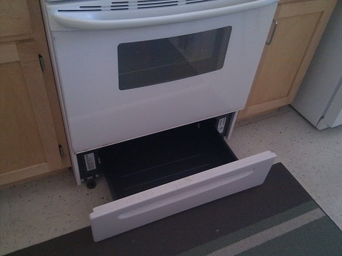
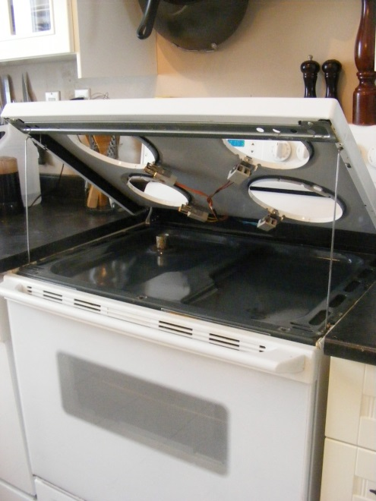

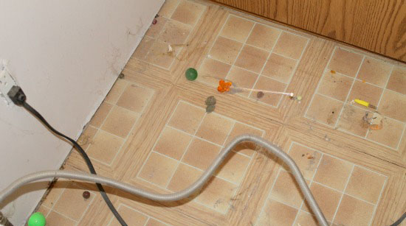
- Clean microwave thoroughly, including grease that might build up underneath and filter throughout the year.
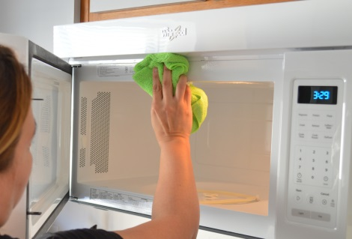
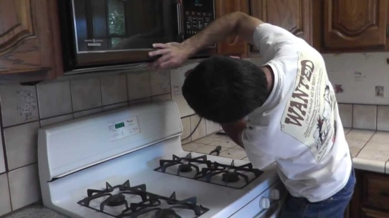

- Clean shower doors thoroughly, including tracks.

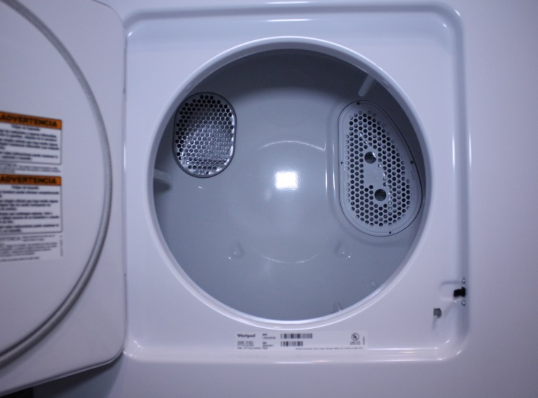
- Clean top, inside and sides of Washer/Dryer. Don’t forget to clean/wash lint trap.
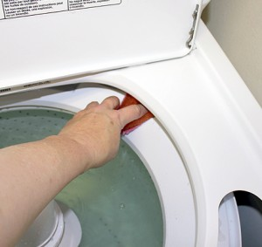

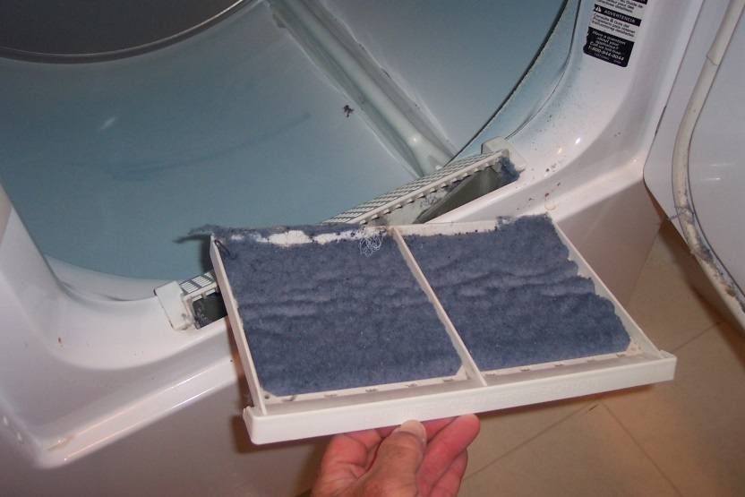

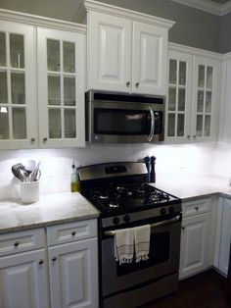
- Clean all cabinets inside and out… especially outside of cabinet doors.

- Clean ceiling fans thoroughly, especially blades.

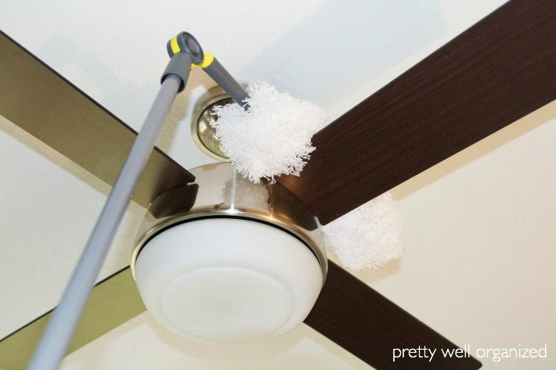

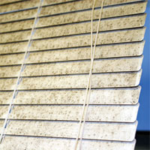
- Mini blinds which are broken or stained can be replaced by visiting your local hardware store. All blinds in apartment must match color and style. You can save money by replacing blinds on your own to avoid labor charges.
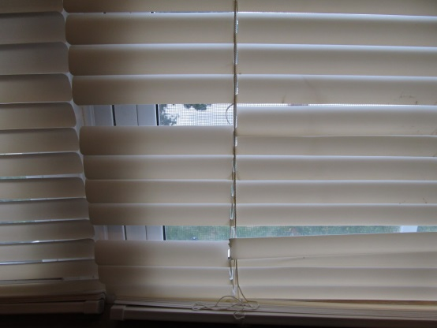

- Painting may be very costly; therefore, it is important to clean or paint any blemish on wall which was made during your stay. Paint color is “First Site White”. You can also try cleaning agents to see if the stain, scuff etc. can be removed without painting.
